Chapter 5

**K-Mean**

**5.1 Taking Red and Green**

**Class 1**

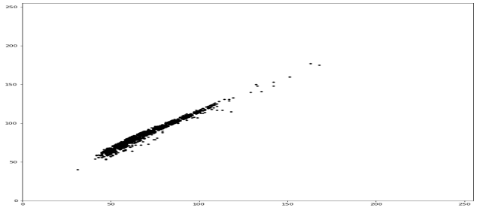

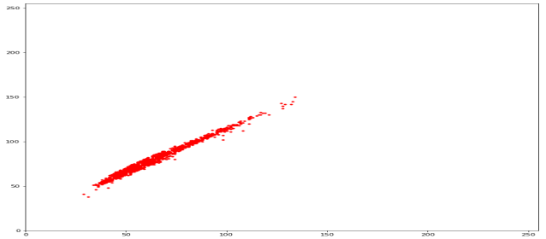**Class 2**

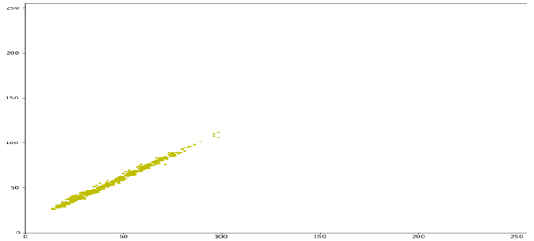**Class 3**

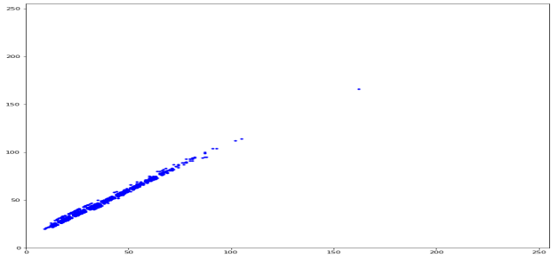

**Class 4**

**Kmean algorithm**

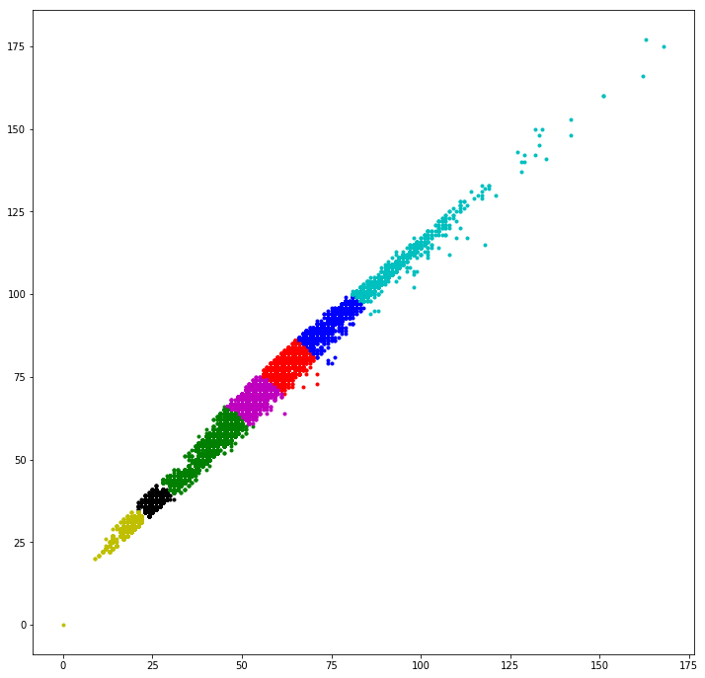

**Centroids point:**

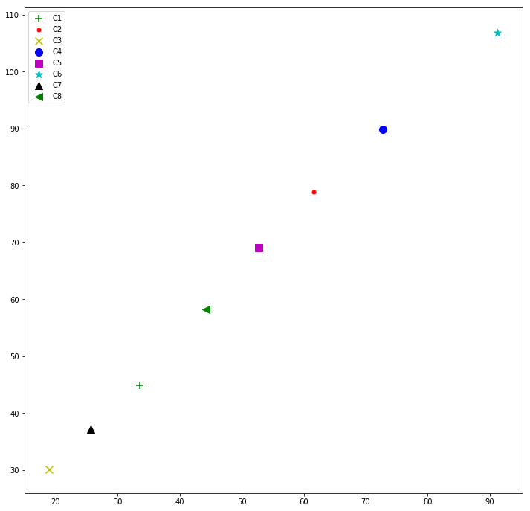

**Class 1 centroid count:**

C1 = 1

C2 = 3672

C3 = 1

C4 = 3195

C5 = 2097

C6 = 828

C7 = 0

C8 = 206

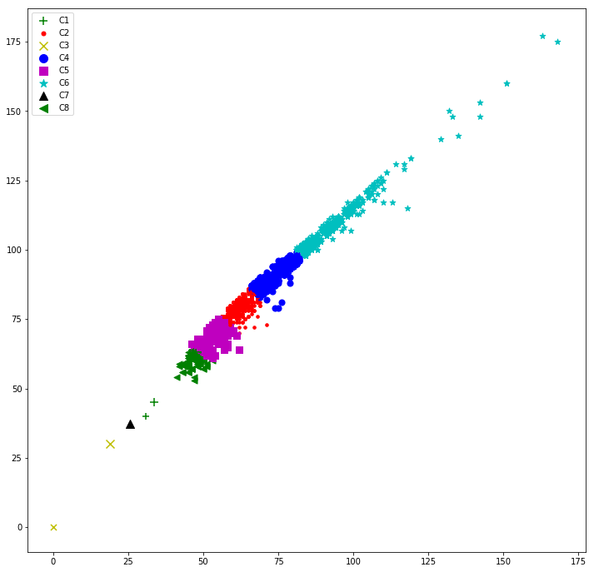

**Class 2 centroid count**

C1 = 25

C2 = 2108

C3 = 1

C4 = 941

C5 = 3814

C6 = 379

C7 = 2

C8 = 2731

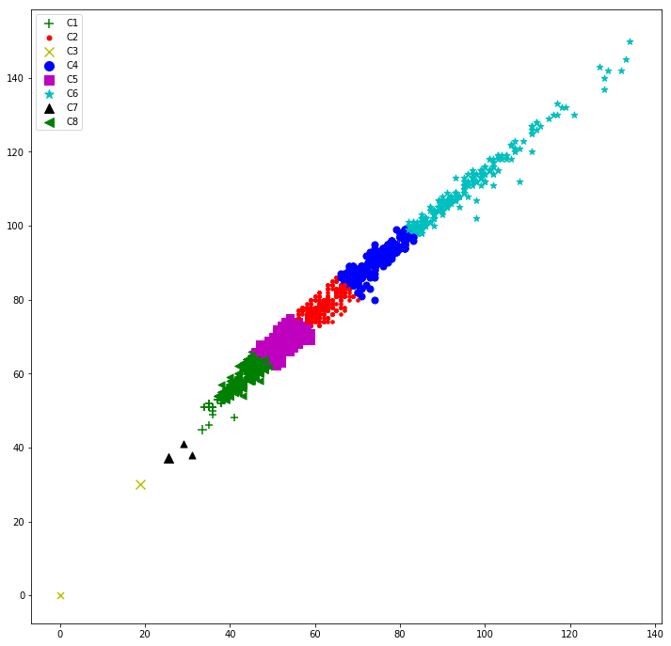

**Class 3 centroid count**

C1 = 3253

C2 = 178

C3 = 1358

C4 = 49

C5 = 393

C6 = 7

C7 = 3358

C8 = 1405

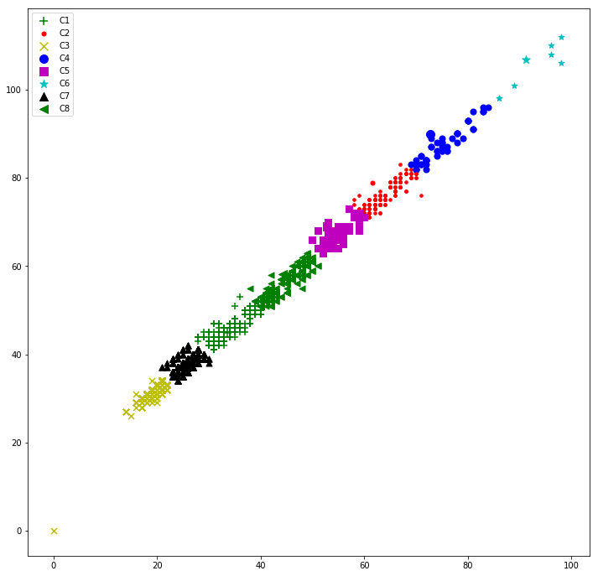

**Class 4 centroid count**

C1 = 2146

C2 = 86

C3 = 3657

C4 = 33

C5 = 196

C6 = 10

C7 = 3338

C8 = 535

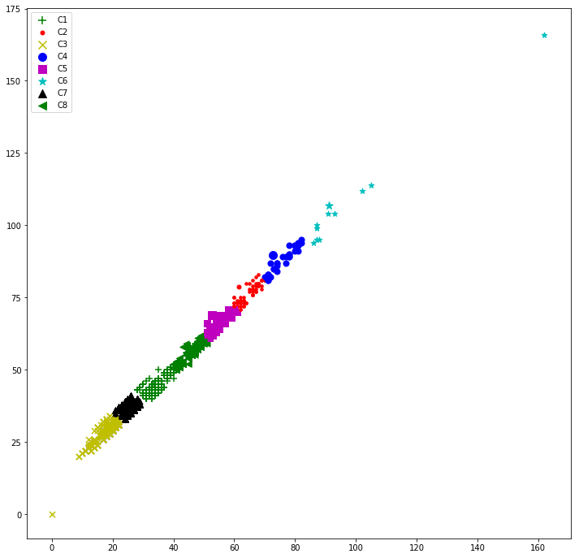

**5.2 Taking red and blue**

**Class 1**

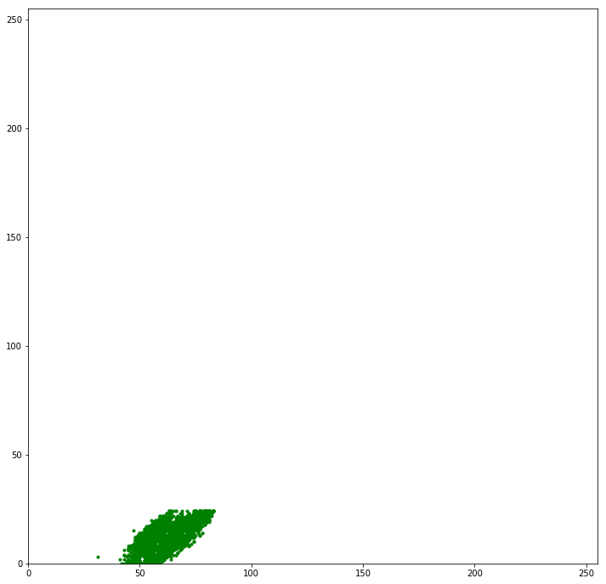

**Class 2**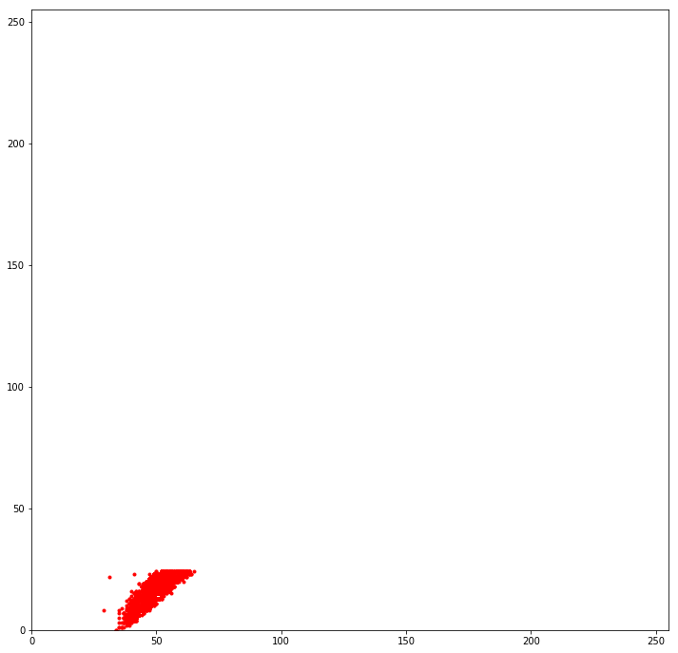

**Class 3**

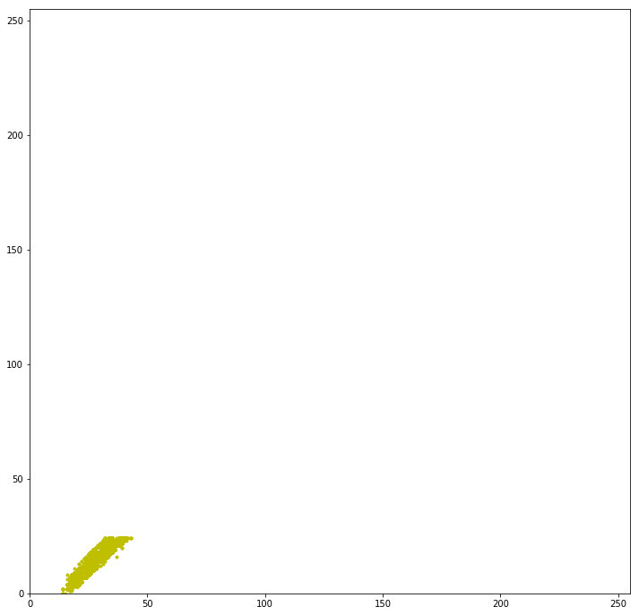

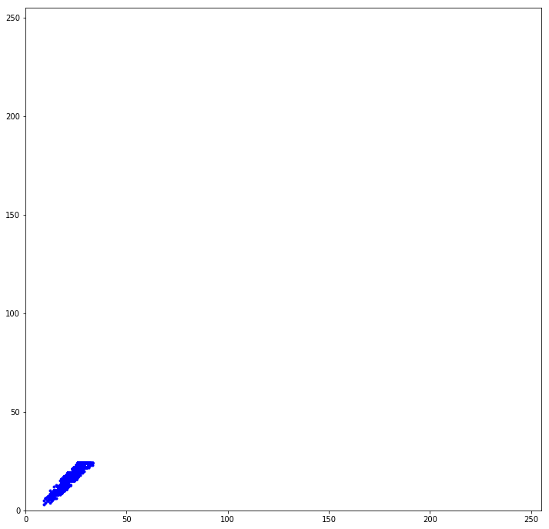**Class 4**

**K mean Centroids area**

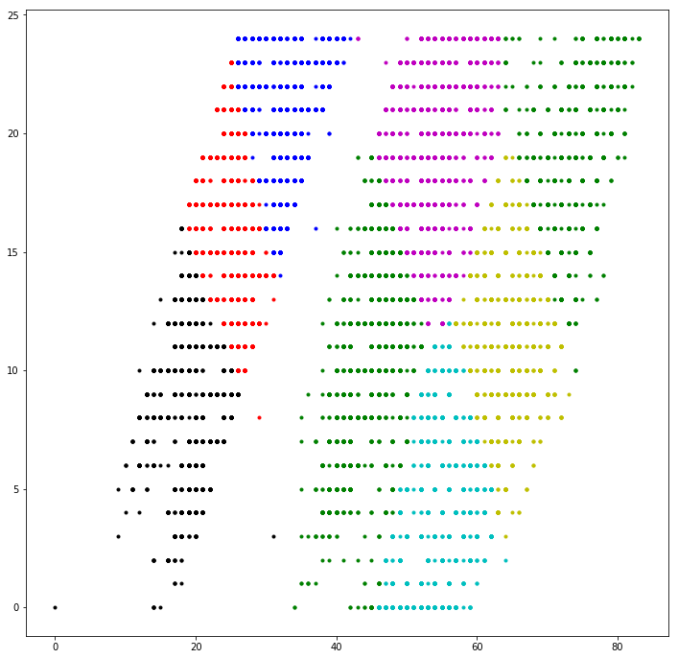

**Centroid point**

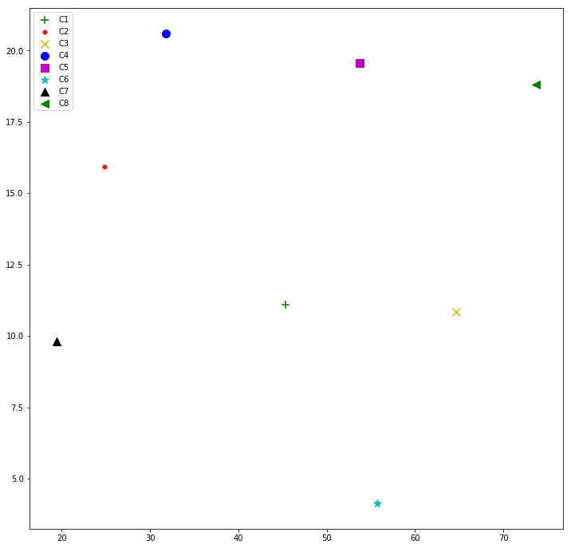

**Class 1 centroid count**

C1 = 260

C2 = 0

C3 = 3129

C4 = 0

C5 = 362

C6 = 3146

C7 = 2

C8 = 1992

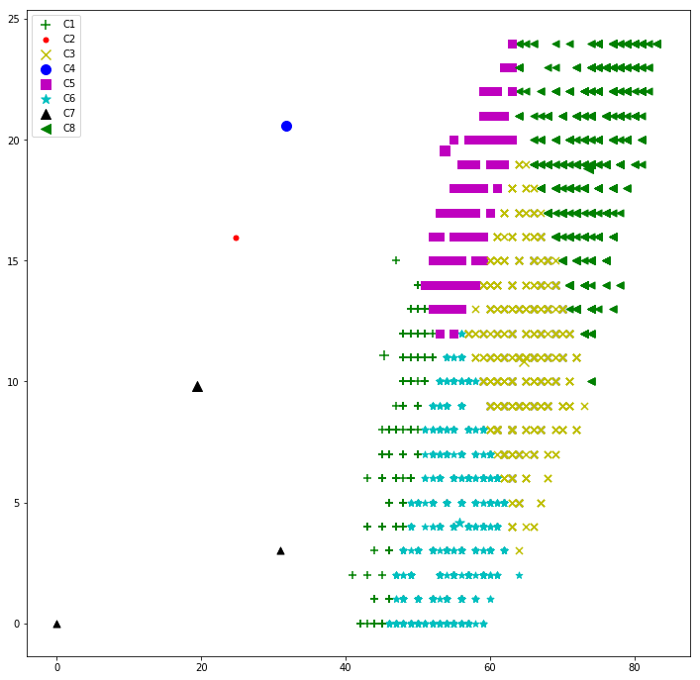

**Class 2 centroid count**

C1 = 3181

C2 = 1

C3 = 0

C4 = 2

C5 = 3542

C6 = 0

C7 = 1

C8 = 3

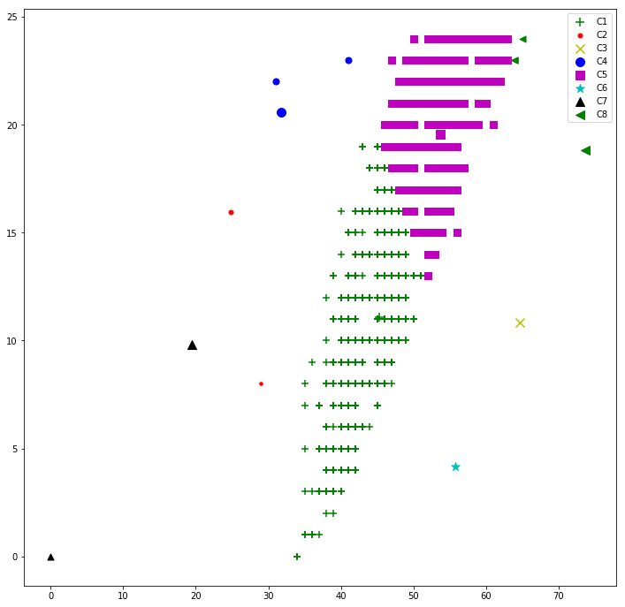

**Class 3 centroid count**

C1 = 0

C2 = 2553

C3 = 0

C4 = 3001

C5 = 3

C6 = 0

C7 = 2223

C8 = 0

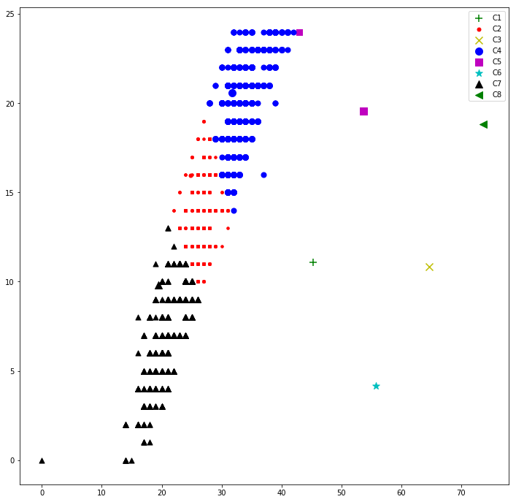

**Class 4 centroid count**

C1 = 0

C2 = 3123

C3 = 0

C4 = 1367

C5 = 0

C6 = 0

C7 = 2726

C8 = 0

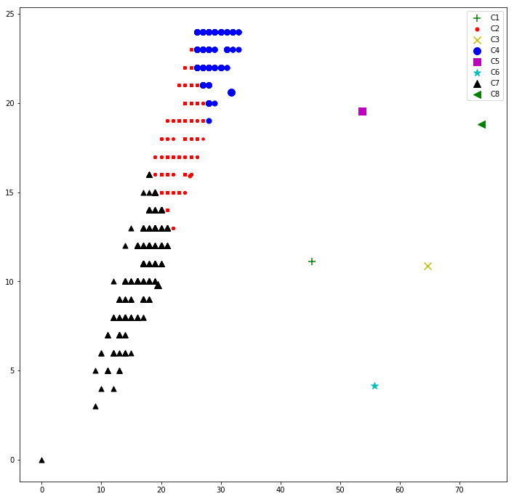

**5.3 Taking Green and Blue**

**Class1**

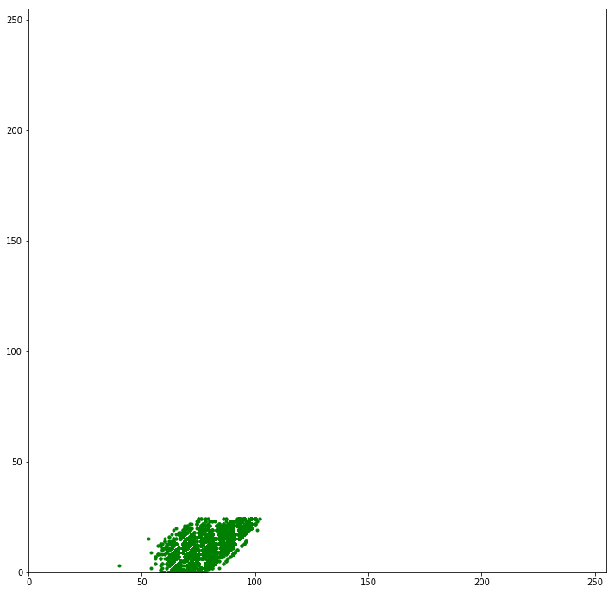

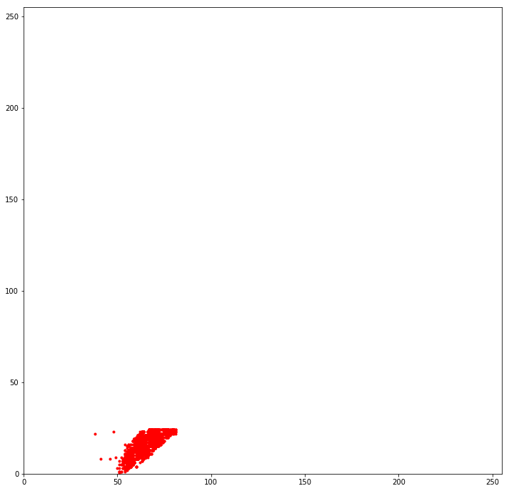**Class2**

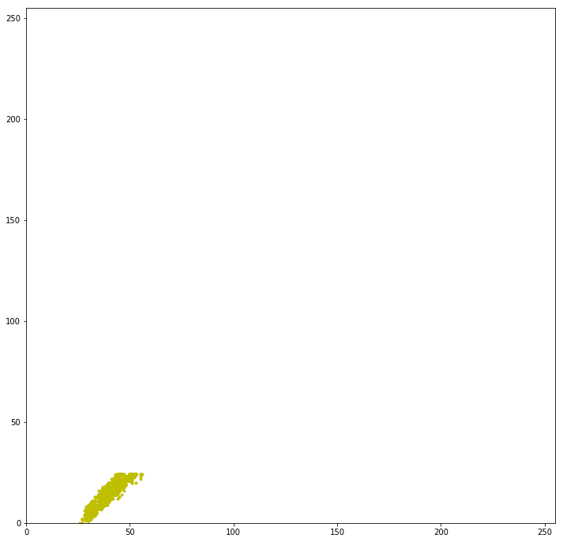**Class3**

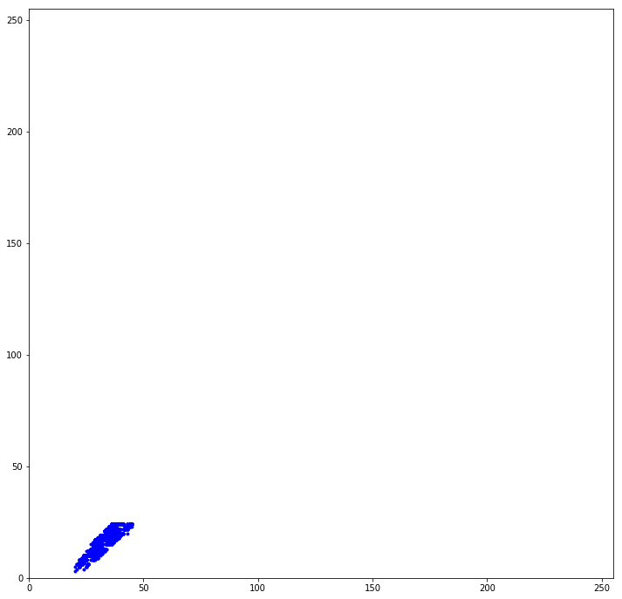**Class 4**

**Kmean centroids**

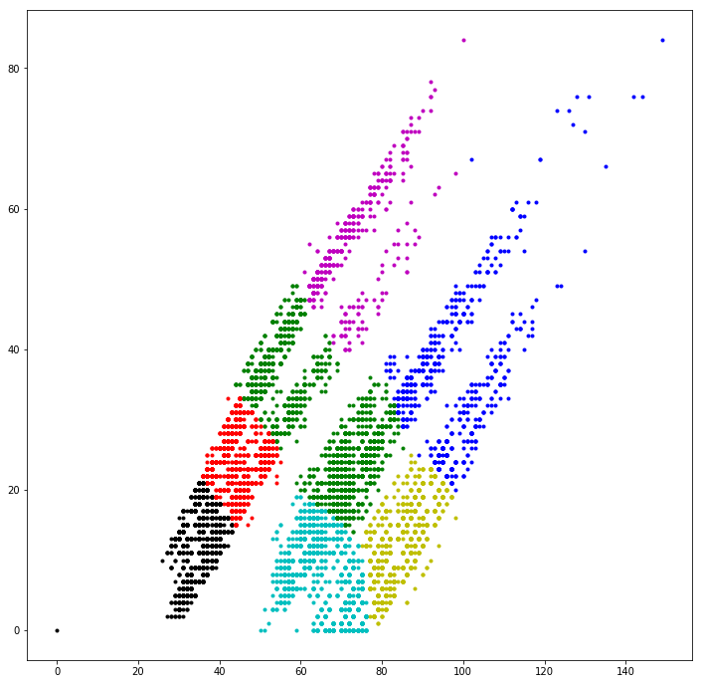

**Centroids point**

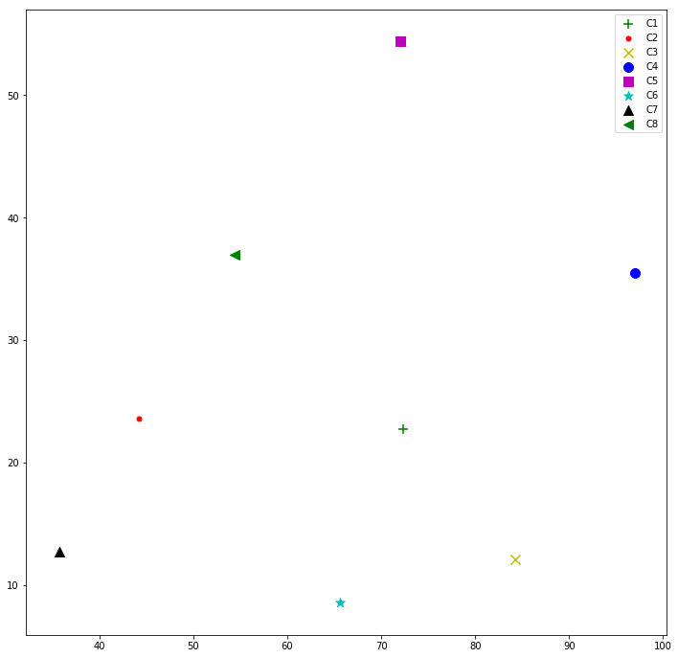

**Class 1 centroid count**

C1 = 67

C2 = 0

C3 = 1412

C4 = 331

C5 = 0

C6 = 690

C7 = 1

C8 = 0

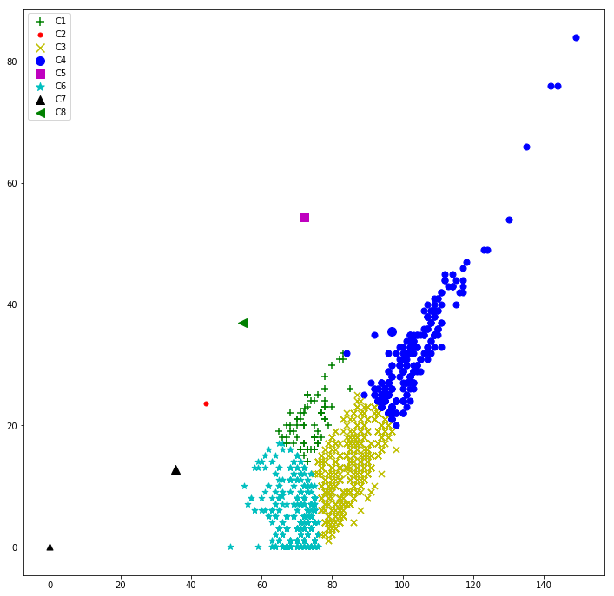

**Class 2 centroid count**

C1 = 1282

C2 = 0

C3 = 0

C4 = 379

C5 = 0

C6 = 839

C7 = 1

C8 = 0

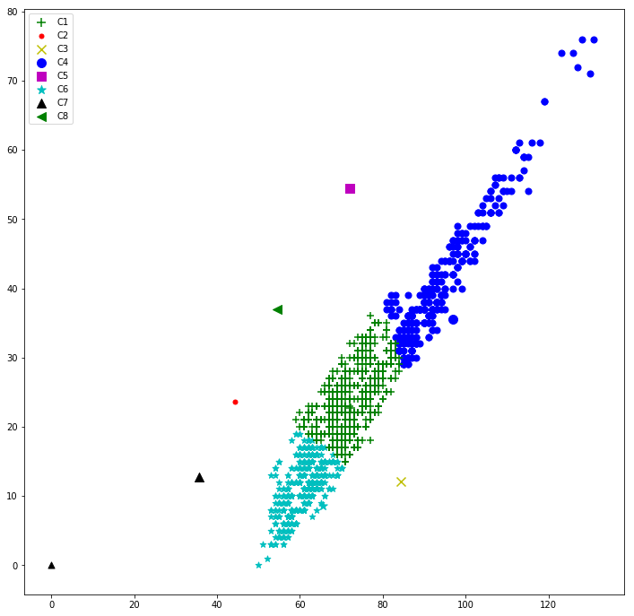

**Class 3 centroid count**

C1 = 0

C2 = 886

C3 = 0

C4 = 1

C5 = 74

C6 = 0

C7 = 1243

C8 = 297

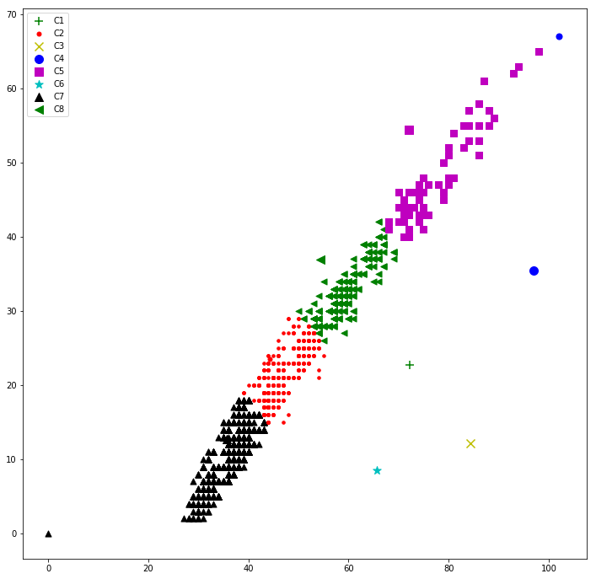

**Class 4 centroid count**

C1 = 0

C2 = 852

C3 = 0

C4 = 0

C5 = 347

C6 = 0

C7 = 585

C8 = 717

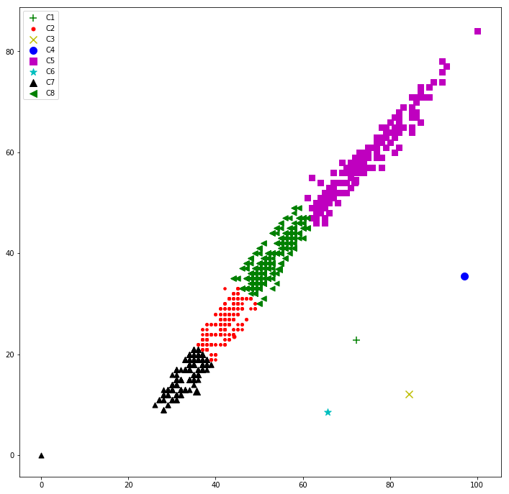

**5.4 Input image to the analyzer**

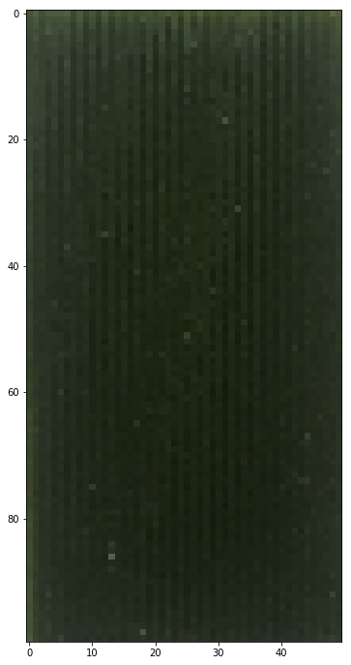

**Centroids count for red and green pixel:**

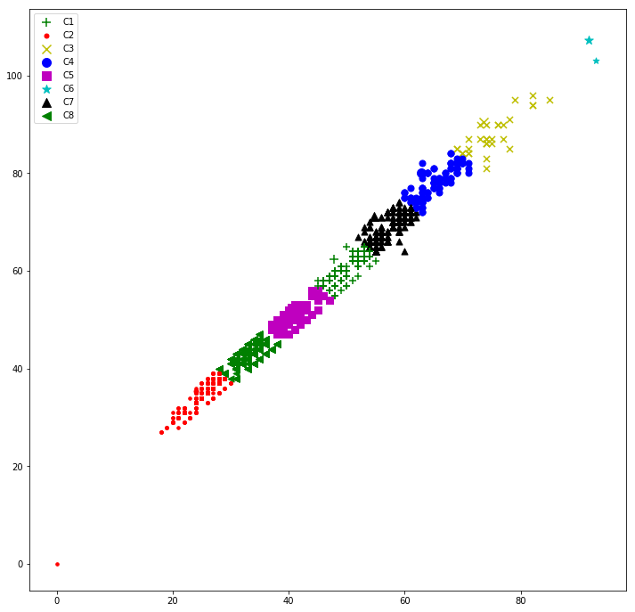

**Centroids count for red and blue pixel:**

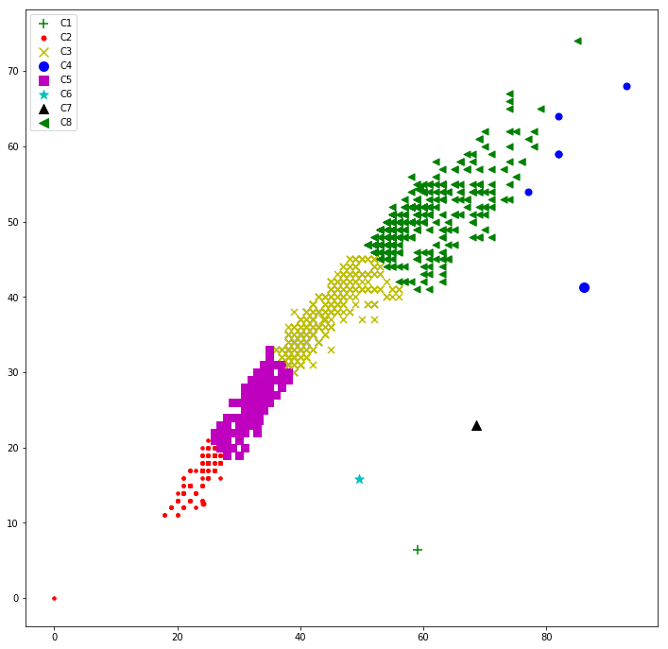

**Centroids count for green and blue pixel:**

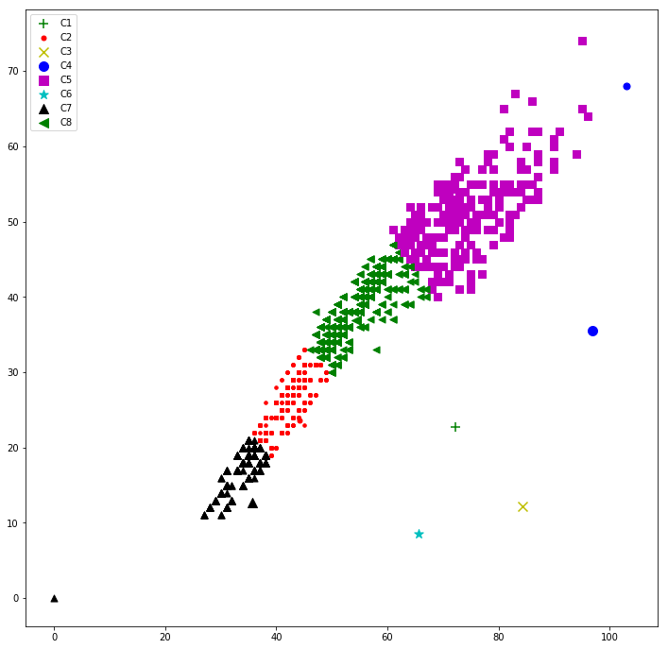

**Output**

Sum RG : [0.14168833753600002, 0.109038845952, 0.0020931069759999987, 0.0009456919199999996]

Red and Green : 3

Sum RB : [0.34012618627999996, 0.451446573608, 0.05615836229600003, 0.0031176063460292757]

Red and Blue : 3

Sum GB : [0.324513824264, 0.29710488730400003, 0.029392970423999992, 0.0017341099919999997]

Green and Blue : 3